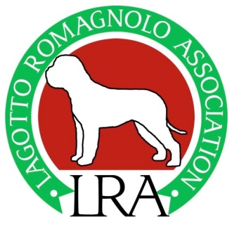 | LAGOTTO ROMAGNOLO ASSOCIATION  REQUIREMENTS OF A DOG SHOW JUDGE  (Rules and Regulations)  Saturday 11th FEBRUARY 2018  Briars Centre, Briars Avenue, Lightwater, Surrey, GU18 5UN  STARTING 10am TRAINER – CAROLE SMEDLEY
The Requirements of a Dog Show Judge (Rules & Regulations) module is currently a part of the three Kennel Club Judges Modules and necessary knowledge for any judge of any breed.

It is also essential learning for any exhibitor, novice or experienced, and judges and all those involved in stewarding, organising shows and events so that they are able to understand what is and isn’t allowed or supposed to happen in a show ring. Even experienced exhibitors and judges benefit from refreshing their understanding, as KC rules and regulations constantly change and have done recently and now has to be repeated every 5 years under the new KC JDF requirements.

The morning session will be a presentation by the Trainer and, after lunch (and the opportunity for revision!), the test paper. Certificates will be provided to the successful candidates.

This seminar with exam will cost each participant £25 which includes a light lunch and refreshments.

Learning material will be e-mailed to you in early 2018, or earlier if received from the KC.

…………………………..…...................................…………………………..…...................................

REQUIREMENTS OF A DOG SHOW JUDGE
(Rules and Regulations)

Saturday 11th FEBRUARY 2018

Please reserve me a place on this seminar:

NAME ………………………………………………………………………………………………………………………………………………………..
ADDRESS …………………………………………………………………………………………………………………………………………………..
E-MAIL ……………………………………………………………………………………… Tel No………………………………………………….

If you have any special dietary requirements, please state here……………………………………………………………….

…………………………………………………………………………………………………………………………………………………………………..

Full Session (with exam) £25 each

This booking slip and cheques for (made payable to the LRA) should be sent by 29th January 2018 to:

Mrs A Stephenson, 33 Guildford Road, Lightwater, Surrey, GU18 5RZ

If you prefer to pat by direct Bank Transfer, please contact Ann Stephenson for details. asteph33@aol.com or 01276 471064

